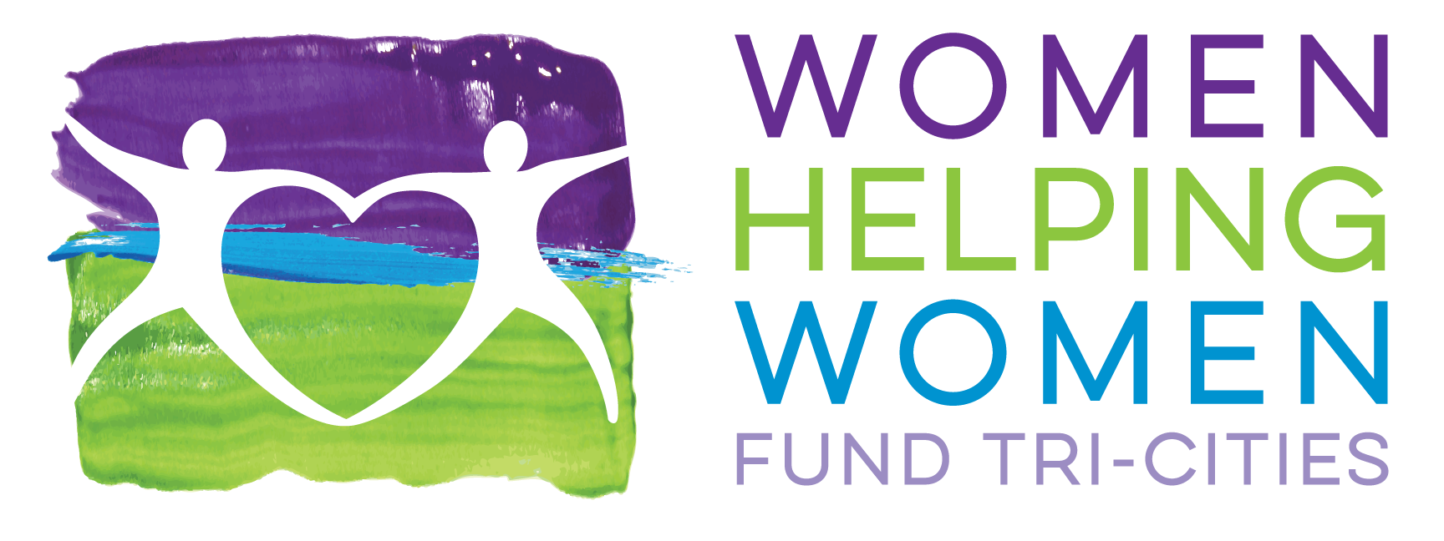
WHWFTCTC Office Use Only
No.________________
Application for Funding for Grant Year January 1, 2025 – December 31, 2025
PROPOSAL COVER PAGE
Please complete this cover page and submit one original and twelve copies with your proposal packet.
Agency Name: Agency EIN or FIN:
Address:
Executive Director:
Telephone Number: Fax Number:
Email:
Website:
Name and email address of contact person for this Application if different than Executive Director:
Agency Fiscal Year:
Agency Mission Statement:
Name and brief description of Agency program proposed for funding (100 word limit):

These amounts must match your budget worksheet:
Box #1: Total Cost of This Program: $ ______________

Box #2: Amount Requested from WHWF-TC $______________

Box #3: Percentage of Total Program Cost
Represented by this Request _______________%

Is this a new or existing program? ☐ New☐ Existing Date of Program Start:____________

SECTION A: 2025 PROPOSED PROGRAM NARRATIVE (5 page limit)
Overview of Agency: Provide a brief description of your agency, its history, area(s) of focus and how the proposed program fits within your agency as a whole. (Maximum 250 words)
Program Name:
Desired Result:
- List the Desired Result(s) your program or this plans to achieve that align with the mission of the Women Helping Women Fund Tri-Cities. You may list more than one Desired Result, but please be as focused as possible. Each Desired Result you list must be fully addressed throughout this Application.
Demographic Information: (Maximum 250 words)
- Describe the population your program is designed to serve (i.e. general demographic information such as gender, socioeconomic status, racial/ethnic mix of current program participants). in order to address the Desired Result(s) identified above.
- Use the following table to identify any specific eligibility criteria you use:
Eligibility Criteria
Age
Income
Health status
Disability status
Other
Other

Need for the Program: (Maximum 500 words):
- Explain any issues, challenges, and/or barriers affecting the population you propose to serve using key indicators, baseline data, and other statistical data.
- Describe how your program improves the lives of women and children in the Tri-Cities area by assisting in their care and development.
- Identify how your program offers preventive strategies and/or proactive initiative in the priorities listed on the Women Helping Women Fund Tri-Cities website.
Program Description: (Maximum 500 words)
  - Describe the key components of your program in a manner that demonstrates how it will (i) respond to the need explained above, and (ii) help achieve the Desired Result(s) identified above.
Program Quality: (Maximum 500 words)
- Describe the strategies and methods your program will use to ensure and monitor program quality. These may include, but are not limited to, the following:
- Information on the research base for your program;
- Program philosophy and service delivery standards (for example, client/staff ratio);
- Prior evaluations/results of the program; and/or
- Qualification and training of program staff and volunteers.
- Describe how you will define and measure the results this program intends to achieve. Explain any assessment tools, surveys, etc. you will use to collect this information.
- If this is an existing program, provide data (for the past 3-5 years) to support your long-term performance. Include any lessons learned, challenges experienced, and program changes.
Collaborative Relationships: (Maximum 250 words)
- Identify your key organizational partners and describe how you will collaborate with them to deliver your program and achieve results for the target population.
- Do other agencies/programs in the community provide services similar to this program?

Leveraged Resources: (Maximum 250 words)
  - Describe your current fundraising strategy.
  - Does your agency have other committed sources of funding that will support the sustainability of this program?
SECTION B: BUDGET NARRATIVE AND BUDGET WORKSHEET (1-page limit)
- Complete the attached Program Budget Worksheet for the period January 1, 2025- December 31, 2025.
- List the following amounts from your completed Program Budget Worksheet:
- Total Program Expenses:
- Amount Requested From WHWFTC:
- Percentage of Total Program Revenues represented by this funding request:
- Describe exactly how you will use WHWFTC funding, if approved, to support this program.

AUTHORIZATION STATEMENT*

We, the undersigned, agree to abide by the conditions set forth in this application.
We understand that as a condition of receiving funds from Women Helping Women Fund Tri-Cities, we must submit to WHWF-TC two (2) Progress Reports, one in June, 2025 and one in December, 2025. In these reports our agency is expected to describe the programs goals and objectives, then implementation of program activities and resulting outcomes, and a statement of the impact our program has had in the community.
We understand that the funding received from WHWF-TC is to be used only for the purpose of the proposed program and must be expended within twelve months of the award. Unless a commitment to the contrary has been expressed in writing, WHWF-TC grants are for one year only, and must not be construed as an implied commitment on the part of WHWF-TC to respond favorably to future grant requests. At the termination of the grant year, all unexpected funds must be returned to Women Helping Women Fund Tri-Cities by February 1, 2026.
We further understand that programs will be selected and notified by July 31, 2024. This selection will be confidential; public announcement of the selected programs will be made at the October, 2024 luncheon. Any disclosure of selection prior to the annual luncheon could affect the status and/or the amount of the grant funds.
The amount of the grant funds received by our program will be determined by the proceeds of the October 2024 luncheon and may be less than the full amount requested. Final grant amounts will be determined following the luncheon, when grantees will be notified of the exact funding amount. Half of the total grant amount will be disbursed in December 2024 at a meeting during which program commitments will be reviewed for any changes since the grant request was submitted. The second half distribution will be made in July, 2025 following a mid-year review.
We also understand that, if selected, a representative of our agency will be required to attend and fill a table of 10 at the Annual Benefit Luncheon in October. The cost to attend the luncheon is a minimum donation of $100.00 per person. We also agree to follow all provided timelines for submitting the names of our table captain and our table guest list.
We will publicly acknowledge the Women Helping Women Fund Tri-Cities as a contributor to this program in any communications about the program.

_____________________________________________ _____________________
Executive Director or other authorizing agent of Agency Date
_____________________________________________ _____________________
President or Chairperson of the Board of Directors Date
or other authorizing agent of Agency
*The Authorization Statement submitted with your original grant application packet must include original signatures and dates, not copies.

